Name: M.Abdullah Course Title: Database Systems I

Registration No. : FA21-BCS-135-C Course Instructor: Dr. Abid Sohail Bhutta

# **ASSIGNMENT 03**

**Question 1:**

**Deliverable 3 included the creation of a Relational Schema for the proposed ERD after normalization. Students require to fill the tables either from real organizational data or fabricate it by using a third-party tool or by using faker library of any language.**

**SCHEMA:**

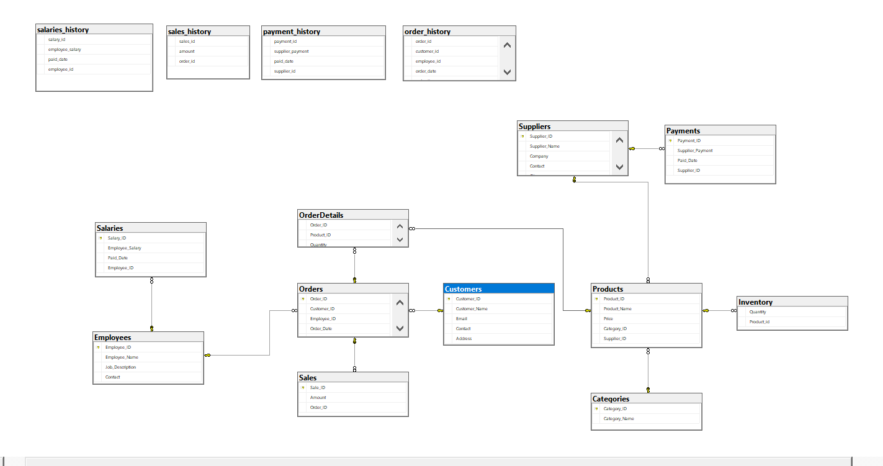

**AFTER DATA POPULATION:**

* **Component Entities:**

Component entities in my project contain 100-500 enteries per entity and are as follows:

* Products
* Employees
* Suppliers
* Customers

Here is the sample data from one of the component entities named as customers:

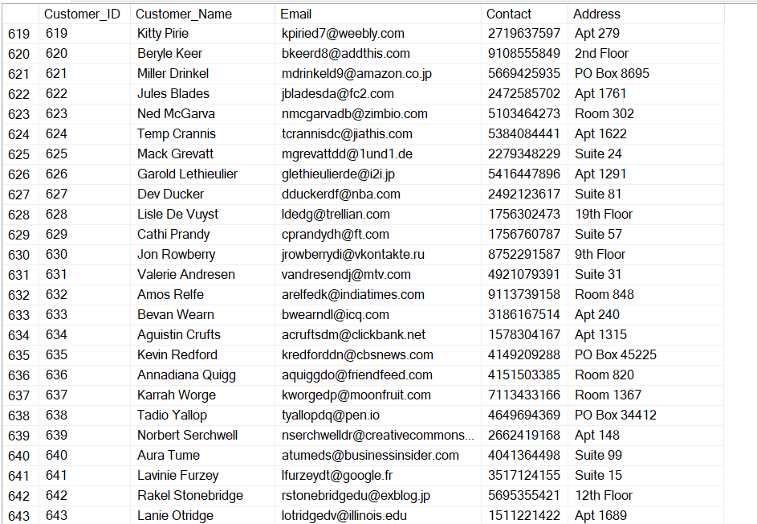

* **Transactional Entities:**

Transactional entities in my system contain 600-1300 records per entity and are as follows:

* Orders
* Order Details
* Payment
* Salary
* Inventory
* Sales

Here is the sample data from one of the transactional entities named as orders:

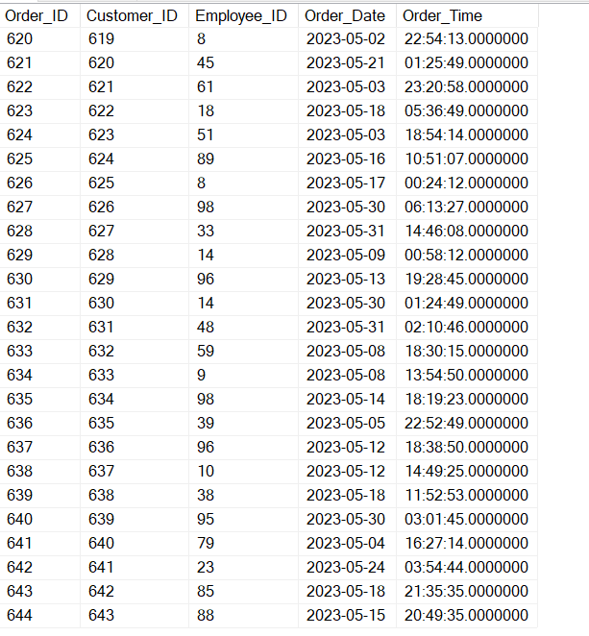

* **Classifying Entities:** Classifying entities involves categorizing a set of data into distinct sections based on specific criteria or requirements. One common example is the use of categories. For instance, consider a Categories Table as I have in my project with 6 entries that are utilized to classify 149 entries within a Products Table.

